**OSINT exercise #003 (Gralhix)**

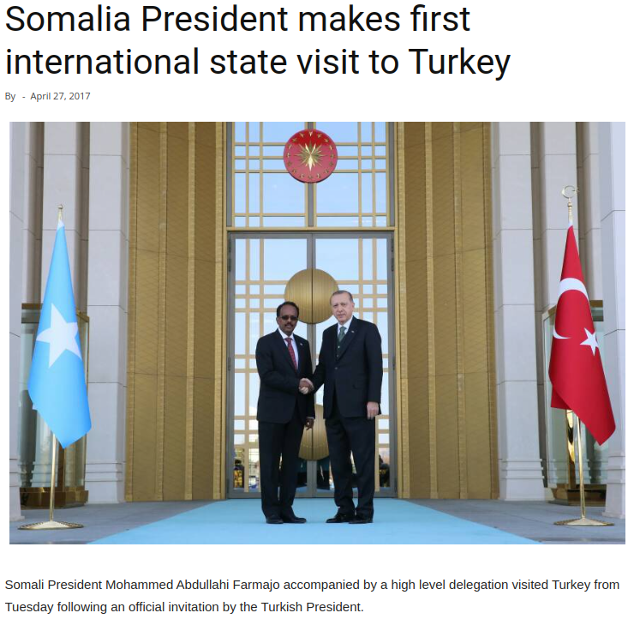

When Google reverse image searching this image, I quickly find an article at atalayar.com with this picture from a different perspective. The subtext for this picture specifies that the picture is taken at the Ankara Presidential Complex. First, I Google this text and find a Wikipedia page with the coordinates for this location (39°55'50.9"N 32°47'56.0"E), which I then enter into Google maps. A pin is dropped on a building, without any photos attached or Google street view images available. I then search in Google images for the Ankara Presidential Complex, until I find pictures with the characteristic golden door. Soon I indeed find a thumbnail of this door in a more zoomed-out perspective, posted by Turkish Minute. In this picture I can see that there are three big golden segments, separated by columns that are each three individual columns. I can identify these same golden segments and column structure in the other images I find of the Ankara Presidential Complex on Google images. Going back to Google maps, the building identified with the Wikipedia coordinates fits the building on Google images, so the coordinates are correct. The coordinates of where the photo exactly was taken are then: 39.930773, 32.798574.